LLP – Comenius”I’LL MAKE YOU LAUGH”
1st Meeting: Ostrava 21st – 27th November 2011

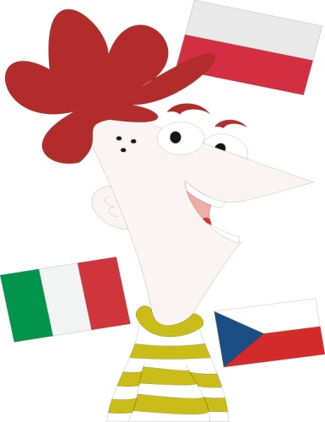

21st November, Monday
Arrival of participants and accommodation in host families

23rd November, Wednesday
Visit of the partner school: The Secondary School of Civil Engineering.
Working sessions.

24th November, Thursday
Meeting with the class engaged in the project.
Visit of Ostrava.

25th November, Friday
Show organized by school for its 60th anniversary.

26th November, Saturday
Working session
Final party.

27th November, Sunday
Flights back

