LLP – Comenius”I’LL MAKE YOU LAUGH”
3rd Meeting: Lubostron 16th – 22th October 2012

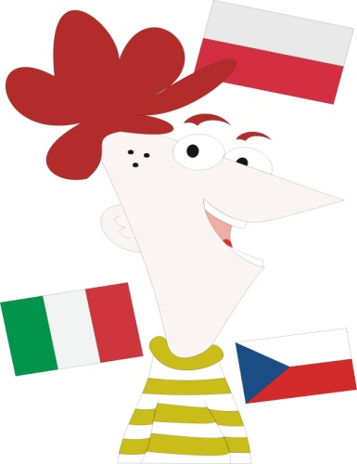
16th October, Tuesday
Arrival and accommodation of participants.
17th October, Wednesday
Meetings, integration, workshops, work on the project's products
18th October, Thursday
Trip to Toruń (Unesco World Heritage + House of Copernicus)
19th October, Friday
Visit at school (working session) and visit in municipality in Łabiszyn. After again work on the project's products and integration activities
20th October, Saturday
Trip to Warszawa, city-sightseeing
21st October, Sunday
Flights back

